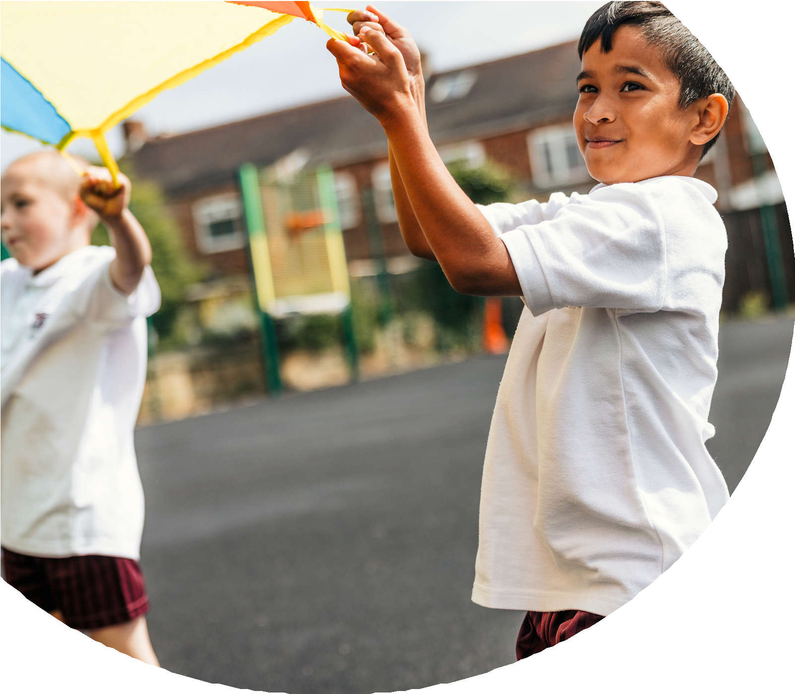
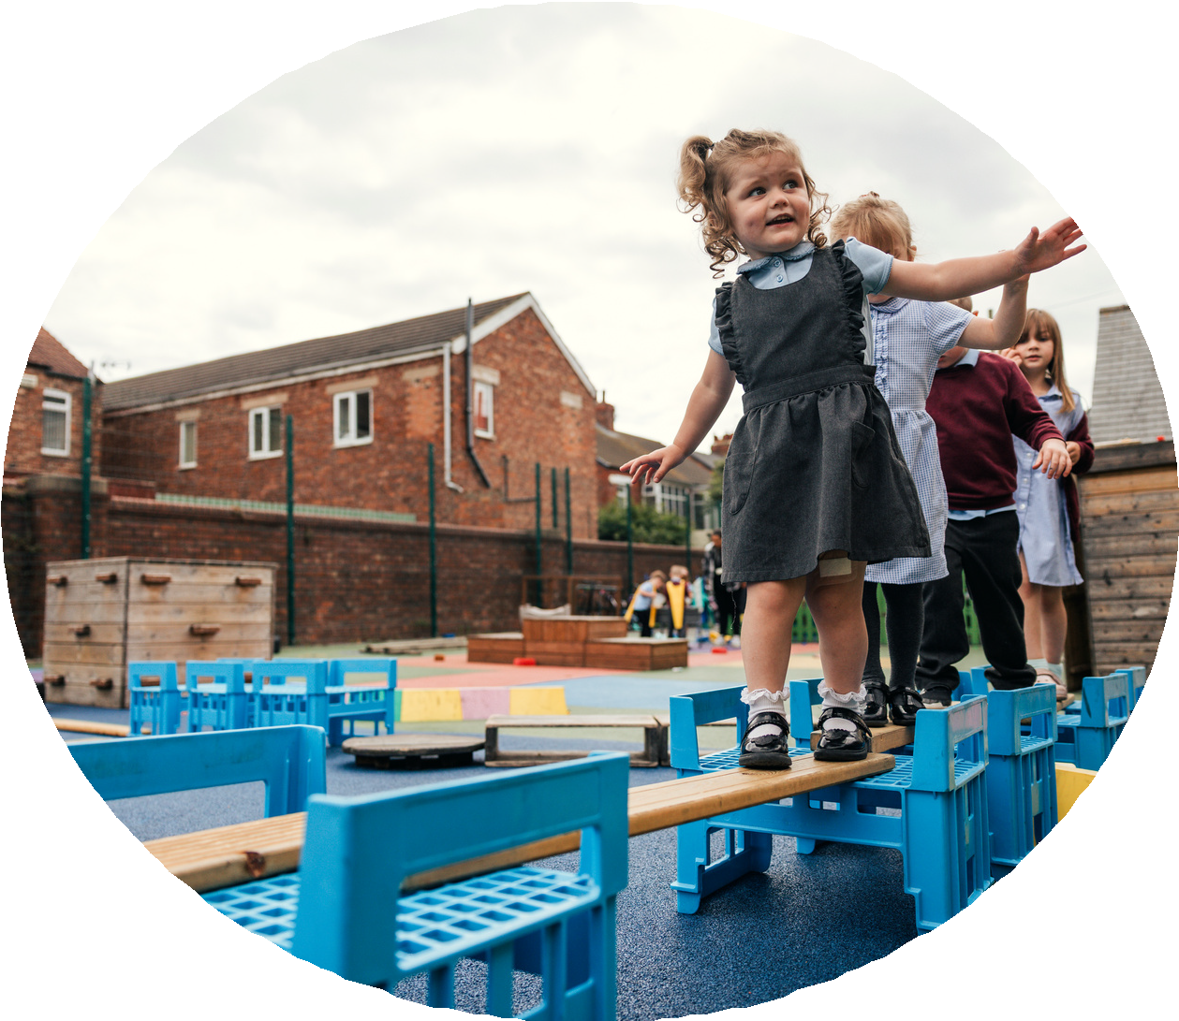

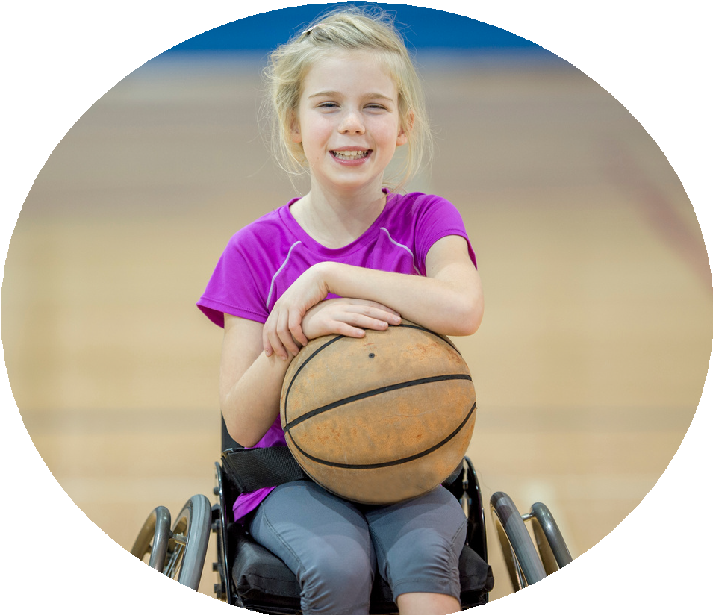



PE and sport premium monitoring and tracking form 2025/2026

Commissioned by

Created by


PE and sport premium monitoring and tracking form
- It is intended that this template should be used as preparation for the completion of the statutory DfE PE and sport premium digital expenditure reporting return. You can upload data (including swimming) from this template onto this platform once it becomes accessible.
- The template is a working document that you can amend and update during the year.
- Before you decide how you are going to use the funding for this academic year you should reflect and evaluate the impact of your use of you PE and sport premium funding in 2024/25.
- You should use your evaluation of last year’s funding to help you decide what to do this academic year, how you will do it, and what impact you expect it to have.
- All spending of the funding must conform with the terms outlined in the conditions of grant
- The summative digital expenditure reporting from June 2026 will continue to include swimming and water safety information. PE and sport premium funding can be used to provide top-up lessons, where necessary, to ensure pupils meet national curriculum swimming requirements
- To ensure funding is used effectively and based on your school’s needs; guidance and examples of best practice across schools can be found here.
- You must use the funding to make additional and sustainable improvements to the PE and sport in your school.
- You must develop and add to the PESSPA activities that your school already offers.

Useful Links:
- PE and sport premium for primary schools - GOV.UK
- PE and sport premium: conditions of grant 2025 to 2026 - GOV.UK
- It is intended that this template should be used as preparation for the completion of the statutory DfE PE and sport premium digital expenditure reporting return. You can upload data (including swimming) from this template onto this platform once it becomes accessible.
- The template is a working document that you can amend and update during the year.
- Before you decide how you are going to use the funding for this academic year you should reflect and evaluate the impact of your use of you PE and sport premium funding in 2024/25.
- You should use your evaluation of last year’s funding to help you decide what to do this academic year, how you will do it, and what impact you expect it to have.
- All spending of the funding must conform with the terms outlined in the conditions of grant
- The summative digital expenditure reporting from June 2026 will continue to include swimming and water safety information. PE and sport premium funding can be used to provide top-up lessons, where necessary, to ensure pupils meet national curriculum swimming requirements
- To ensure funding is used effectively and based on your school’s needs; guidance and examples of best practice across schools can be found here.
- You must use the funding to make additional and sustainable improvements to the PE and sport in your school.
- You must develop and add to the PESSPA activities that your school already offers.

Useful Links:
Complete the PE and sport premium expenditure reporting return - GOV.UK
PE and sport premium for primary schools - GOV.UK
PE and sport premium: conditions of grant 2024 to 2025 - GOV.UK

Review of the last academic year (2024/2025)

Swimming and Water Safety | What went well? Supporting evidence? | What didn't go well? Supporting evidence?
1. Swim competently, confidently and proficiently over a distance of at least 25 metres | Children gained proficiency | Insufficient lessons meant that some children did not meet the target
2. Use a range of strokes effectively (for example, front crawl, backstroke and breaststroke) | Children gained proficiency | Insufficient lessons meant that some children did not meet the target
3. Perform safe self-rescue in different water-based situations | Children gained proficiency | Insufficient lessons meant that some children did not meet the target
- Take some time to reflect on your intent, implementation and impact from last academic year to celebrate your wins but to also think about improvements for the year ahead.
- You do not need to complete every box. Just record the information that is key to your school's priorities and areas of focus.
Remember - Be clear about how you focussed spending on key groups such as SEND, girls and disadvantaged pupils.

Review of the last academic year (2024/2025)
Key areas as outlined in PE and sport premium guidance | What went well? Supporting evidence? | What didn't go well? Supporting evidence?
1. Increasing confidence, knowledge and skills of all staff in teaching PE and sporting activities prioritising CPD and training where needed | Enabled us to provide a high standard of PE throughout the school, allowing teachers to lead high quality PE lessons from detailed planning.
2. Increasing engagement of all pupils in regular physical activity and sporting activities | Catch up swimming – Year 4  More pupils able to swim distances targeted by National curriculum | Want to start swimming earlier
3. Raising the profile of PE and sport across the school, to support whole school improvement | Children on the year 3/4 playground had the opportunity to take part in different sporting activities during lunchtimes. House competitions were run smoothly thanks to the sports council supporting the PE lead
4. Offer a broader and more equal experience of a range of sports and physical activities to all pupils and ensure equal access to sport for boys and girls | All children had the opportunity to take part in forest school sessions throughout the year. A range of different experiences were booked in for the children to take part in including: Skateboarding, Karate, Football skills and golf.
5. Increasing participation in competitive sport | Children were able to go to other schools to compete in different activities. Also transport to athletics finals in Oxford.

Aims for the next academic year (2025/2026)
- Using your whole school priorities, school development plan and previous PE, school sport and physical activity data, set out your aims for the year ahead.
- Think about specific areas of need such as inactive girls, SEND and disadvantaged pupils
- Remember to also input your swimming data and reflections in the table located at the bottom of this page.
- Consider which of the 5 key areas improvements will be focussing on:
- Increasing confidence, knowledge and skills of all staff in teaching PE and sporting activities prioritising CPD and training where needed.
- Increasing engagement of all pupils in regular physical activity and sporting activities
- Raising the profile of PE and sport across the school, to support whole school improvement
- Offer a broader and more equal experience of a range of sports and physical activities to all pupils and ensure equal access to sport for boys and girls
- Increasing participation in competitive sport
Swimming and Water Safety | Input data | Reflections
1. Swim competently, confidently and proficiently over a distance
of at least 25 metres
2. Use a range of strokes effectively
(for example, front crawl, backstroke and breaststroke)
3. Perform safe self-rescue in different water-based situations

Aim | Why? | Key area | Supporting evidence
Continue to raise the profile of sport | Increase range annd participation | 2,3,4 | Pupil voice, success from previous years
Expose children to a wide range of physical activities | Increase physcial opportunities for all | 2,3,4 | Pupil voice, success from previous years
Continue to develop physical play at playtimes | Increased participation | 2,3,4
Provide more opportunities to compete against other schools | Continue to develop children’s talents and abilities | 5 | Teacher feedback, pupil voice
Continue to develop and support staff | Continue to provide high quality PE | 1 | Teacher feedback
Aims for the next academic year (2025/2026)

Plan, monitor and evaluate (2025/2026)
- Please aim to use this as a live working document through the year.

- Keep returning to this to evidence adaptations and progress made through the PESSPA opportunities you provide.

- There is no set number of objectives you must have.

- Make as many or as few as you see fit that will support your aims for the year ahead.

- Consider which of the 5 key areas improvements will be focussing on:
- Increasing confidence, knowledge and skills of all staff in teaching PE and sporting activities prioritising CPD and training where needed.
- Increasing engagement of all pupils in regular physical activity and sporting activities
- Raising the profile of PE and sport across the school, to support whole school improvement
- Offer a broader and more equal experience of a range of sports and physical activities to all pupils and ensure equal access to sport for boys and girls
- Increasing participation in competitive sport

Plan, monitor and evaluate (2025/2026)

Example ob
Continue to raise the profile of sport in school

 | Intent – what is your objective? | Implementation - How will you achieve this? | Impact - What do you hope to see? | Supporting evidence
Plan and monitor | Sport and physical activity continues to be seen as an important part of the school curriculum.  Ensure that pupils have the opportunity to meet standards in swimming. | Elect sports council members. Sports council to have regular meetings to raise the profile of sport in school.Sports council to run daily activities on the playground for other children.  Catch up swimming lessons for Year 4 when appropriate, extra sessions for team coaching | More children involved with physical play. | Playtime observations  Pupil feedback
 | What impact have you seen? | Are the improvements sustainable? How? | Supporting evidence | Approx. cost
Evaluate |  |  |  | £1500 resources  £5000 lessons and coach for top up/ swimming coaching

Continue to be able to develop forest school sessions

 | Intent – what is your objective? | Implementation - How will you achieve this? | Impact - What do you hope to see? | Supporting evidence
Plan and monitor | Expose children to a wide range of physical activities including forest school | Ensure that there is a well planned programme for forest school across the year for all year groups | Increased amount of physical activity and opportunities | Observations  Pupil feedback
 | What impact have you seen? | Are the improvements sustainable? How? | Supporting evidence | Approx. cost
Evaluate |  |  |  | £10 000 teacher time  £2000 resources/ training

Provide further opportunities for pupils to experience a broad range of sports
 | Intent – what is your objective? | Implementation - How will you achieve this? | Impact - What do you hope to see? | Supporting evidence
Plan and monitor | Book in additional experiences: skateboarding, golf and cricket | Book in over the year | High quality sessions | Pupil feedback
 | What impact have you seen? | Are the improvements sustainable? How? | Supporting evidence | Approx. cost
Evaluate |  |  |  | £2000

Continue to participate in competitive sport
 | Intent – what is your objective? | Implementation - How will you achieve this? | Impact - What do you hope to see? | Supporting evidence
Plan and monitor | Transport is the most costly part of participation. Funding this allows the school to take part. | Book transport | More opportunities for pupils to compete competitively against other schools. | List of events attended
 | What impact have you seen? | Are the improvements sustainable? How? | Supporting evidence | Approx. cost
Evaluate |  |  |  | £1500

Continue to develop staff

 | Intent – what is your objective? | Implementation - How will you achieve this? | Impact - What do you hope to see? | Supporting evidence
Plan and monitor | Continue to ensure that pupils receive a high standard of PE | Continue to purchase PE scheme.  PE lead to be released to coach and team teach with other members of staff to boost confidence levels and subject knowledge.  PE CPD courses to be completed by members of staff who need support. | High standard of teaching across the school | Lesson observations
 | What impact have you seen? | Are the improvements sustainable? How? | Supporting evidence | Approx. cost
Evaluate |  |  |  | £900 scheme

This page has been left blank for any notes or supporting information.

