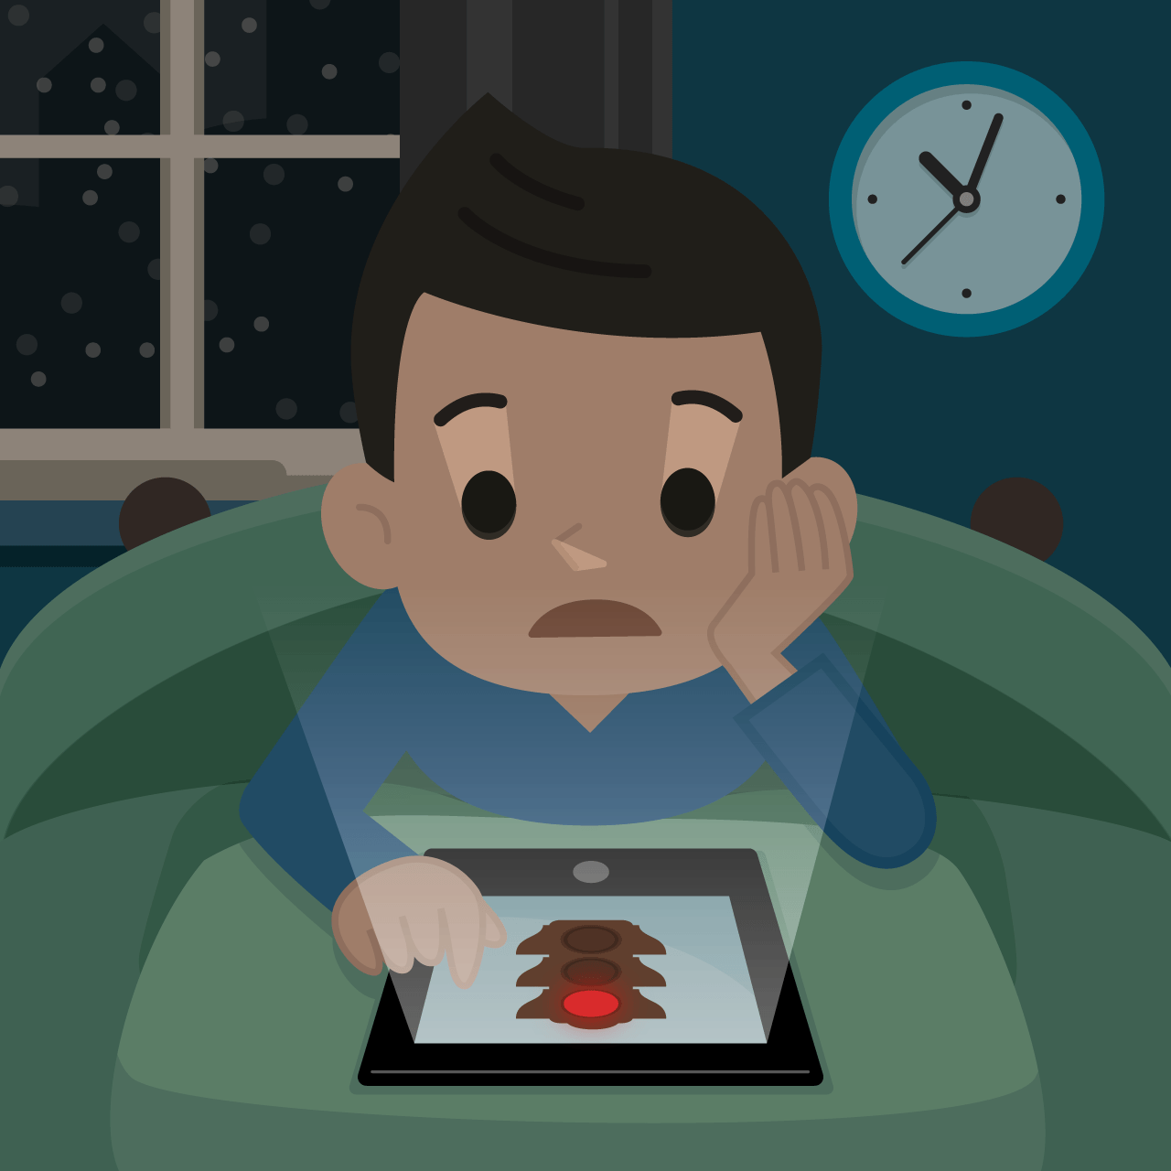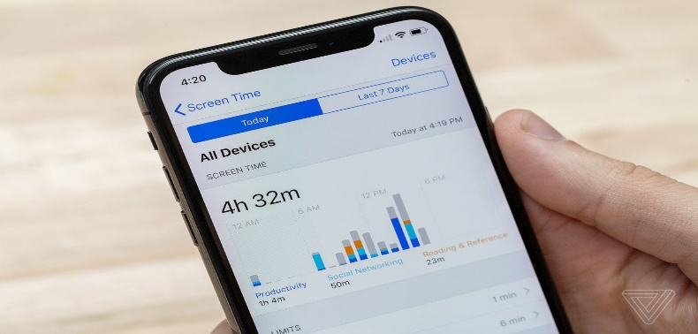

Do you know how to manage your child’s screen time and what they view?

Are you aware that there are parental apps where you can set limits, restrict specific viewing and set bedtime/ wake up time of devices?

A parental Control App makes parenting easier with daily screen time limits, app monitoring, including app blocking,Child tracking, family mode, adult content blocking and more.

- Screen time blocker: Automatically blocks the device once the set time is reached
- Family Parental Control & Family mode tracks and controls what your child accesses on the internet including delicate content and an adult content filter
- Family locator GPS tracker: Tracks your child's phone and sends you the GPS location
There are many parental control free apps. For android phones / google devices, parent link is recommended. The app for I phones is also within the app store app and is called screen time. Installing and setting up is easy.

Start by downloading the parental control app onto your device and follow the instructions to download the children’s parental control companion app onto your child’s devices. Together, these apps allow you to seamlessly manage your child’s daily screen time allowance on all linked mobile and tablet devices.
What you can do
- Set and manage daily screen time limits with screen time blocker
- Block websites or categories (games, gambling, porn)
- Website search and app monitoring
- Safe search to block adult or porn sites
- Unsupported browser blocking

Use Parental Controls to Keep Your Child Safe | NSPCC

